**Lab 2: Ethernet and ARPA**

University of Windsor

Department of Electrical and Computer Engineering

ELEC 8560 – Computer Networks

Semester: Fall 2023

**Student Name**: Amey Mahendra Thakur

**Student number**: 110107589

**Answers:**

1. The 48-bit Ethernet address of the computer used to capture packet in wireshark using given zip file is **c4:41:1e:75:b1:52.**

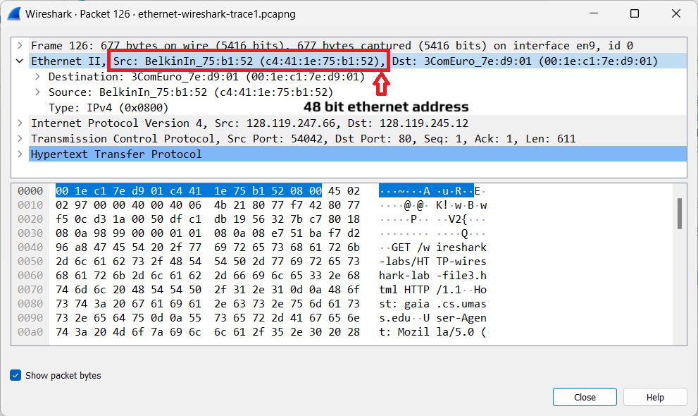

1. The 48-bit destination address in the Ethernet frame is **00:1e:c1:7e:d9:01**. This is **NOT** the Ethernet address of “gaia.cs.umass.edu.” It is the address of my **ComEuro router.**.

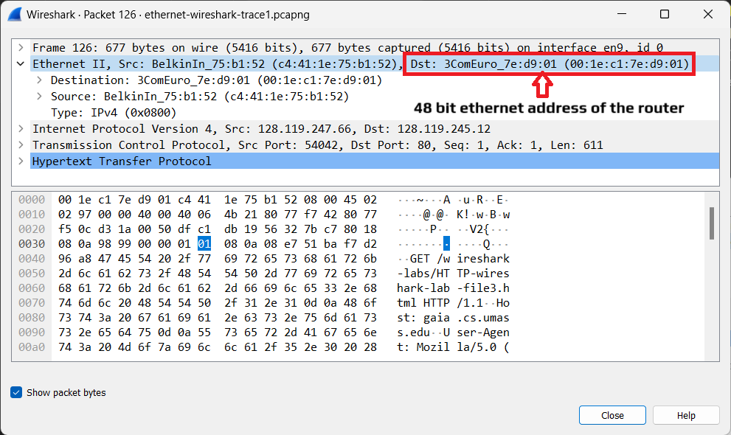

1. The hexadecimal value for the two-byte Frame type field in the Ethernet frame carrying the HTTP GET reques is **0x0800**.

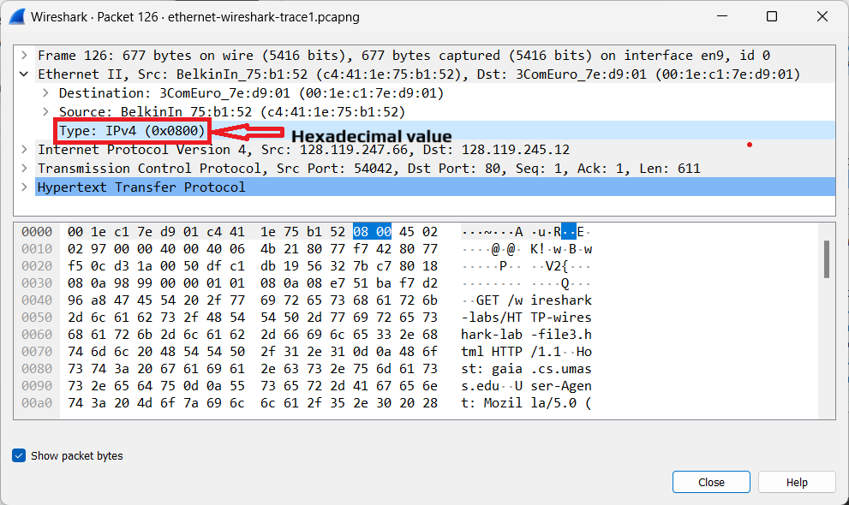

1. I have 66 Bytes before the ASCI character “G” in HTTP GET

Which can be classified as:

No. of bytes in Ethernet Frame: 14

No. of bytes in IP Frame: 20

No. of bytes in TCP Frame: 32

--------------------------------------------

Total Number of Bytes before “G”: 66

--------------------------------------------

After removing the 2 preamble bytes, the resulting data is : 66 – 2 = **64**.

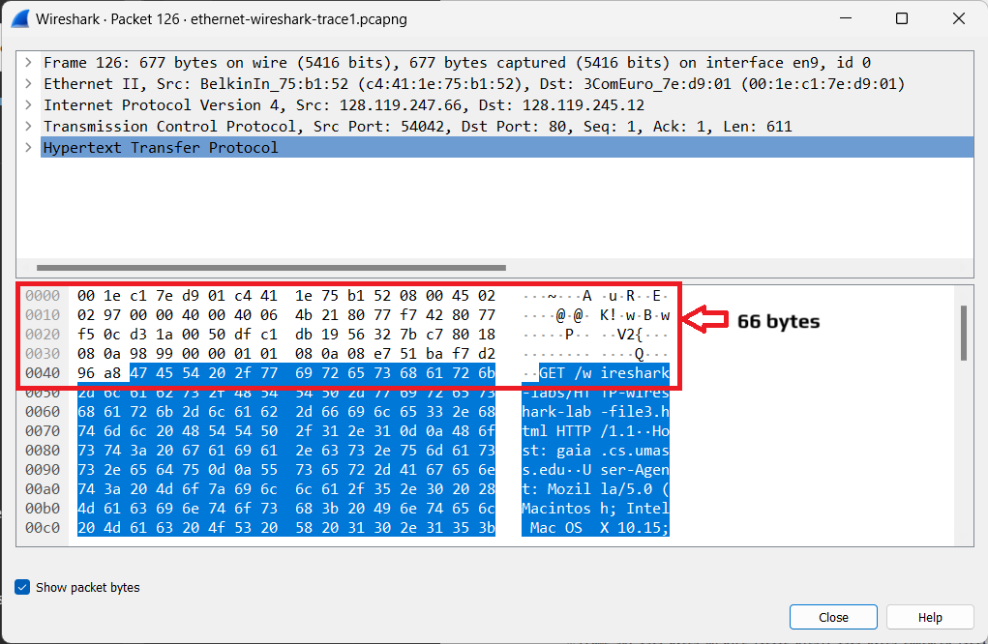

1. The source address **00:1e:c1:7e:d9:01** is neither the Ethernet address of “gaia.cs.umass.edu ” nor the address of my computer. It is the address of **ComEuro router**.

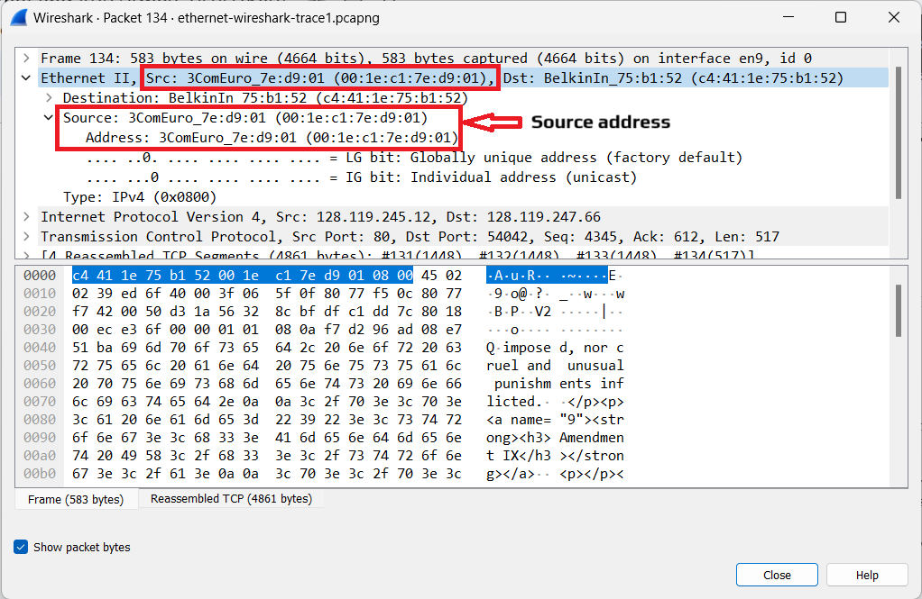

1. The destination address **c4:41:1e:75:b1:52** is the address of my computer.

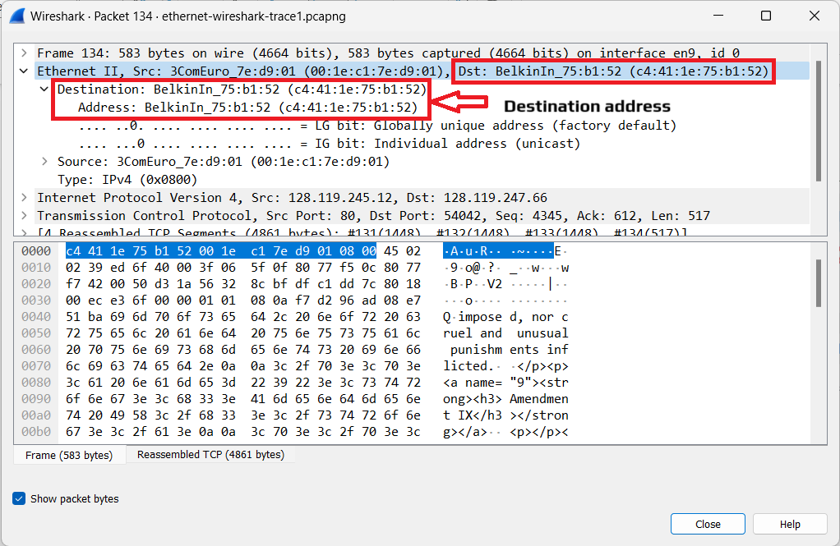

1. The hex value for the Frame type field is **0x0800.** (Note - same as question 3)



1. I have 54 Bytes before the HTTP OK response and in HTTP OK response and I have 13 Bytes before ASCII character “O” in HTTP frame.

Which can be classified as:

No. of bytes in Ethernet Frame: 14

No. of bytes in IP Frame: 20

No. of bytes in TCP Frame: 32

--------------------------------------------

Total No. of Bytes before HTTP OK : 66

No. of Bytes before “O” in the response: 13

---------------------------------------------

Total No. of Bytes before ASCII “O” : 79

---------------------------------------------

After removing the 2 preamble bytes, the resulting data is: **79 – 2 = 77 bytes.**

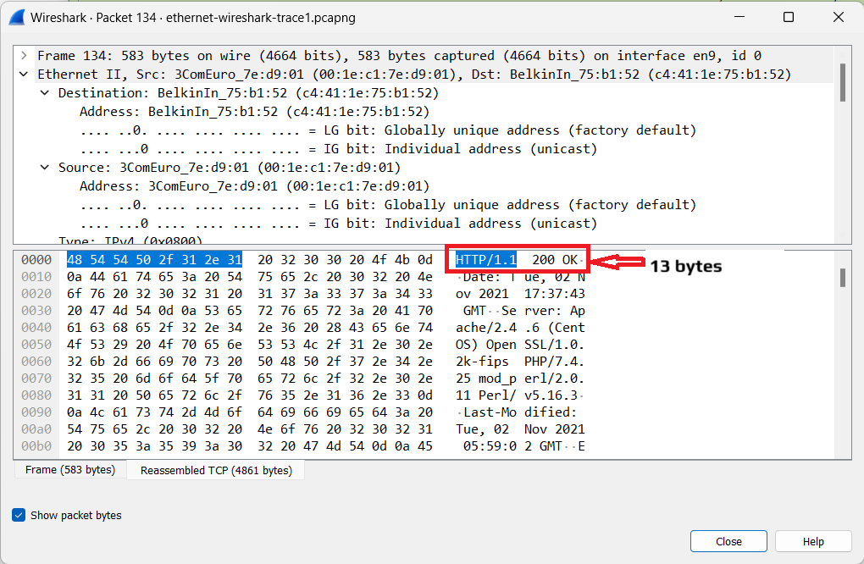

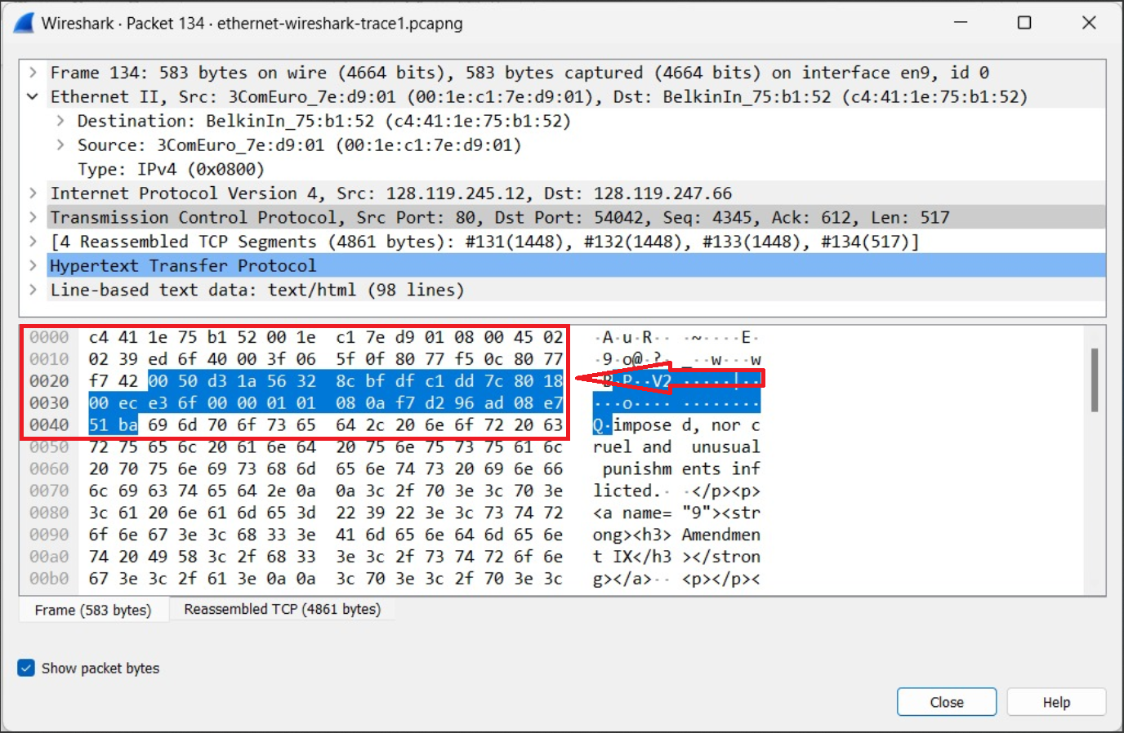

1. **4 Ethernet frames** (each containing an IP datagram, each containing a TCP segment) carry data that is part of the complete HTTP "OK 200 ..." reply message.

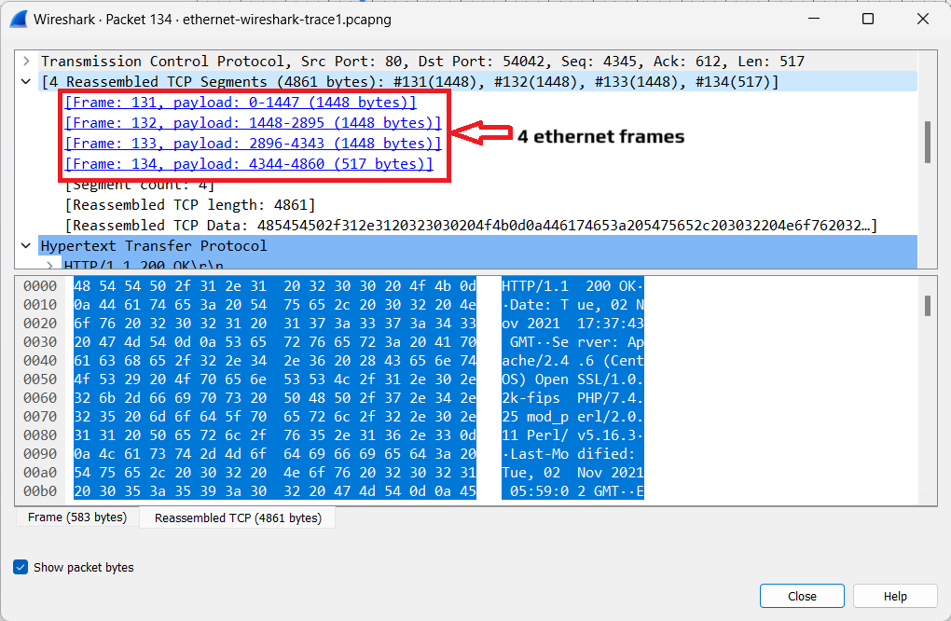

1. There are **2 interfaces** in ARP cache, where first interface had **7 entries** and second interface had **5 entries.**

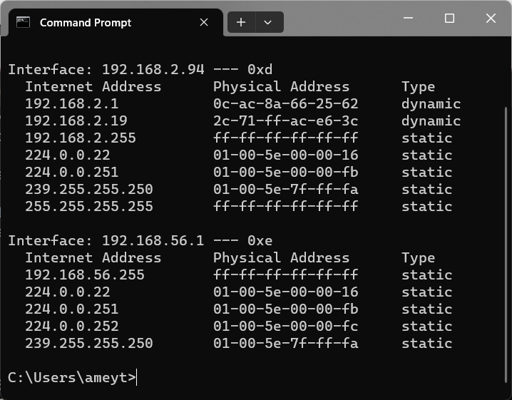

1. What is contained in each displayed entry of the ARP cache

* There are three columns with values representing the IP address, Physical Address and the Type of address.



1. The hexadecimal value of the source address in the Ethernet frame containing the ARP request message sent out by your computer is **00:1e:c1:7e:d9:01**.

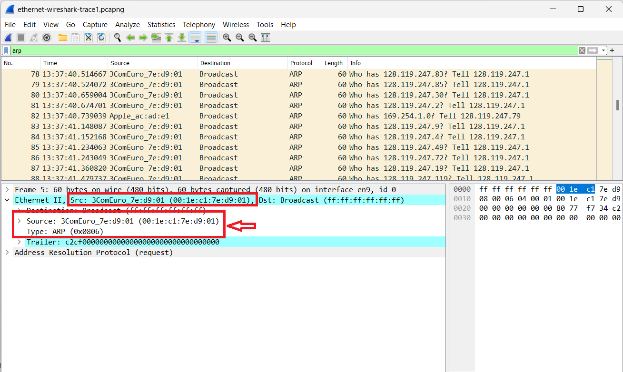

1. The hexadecimal value of the destination addresses in the Ethernet frame containing the ARP request message sent out by your computer **ff:ff:ff:ff:ff:ff** and there is no device.

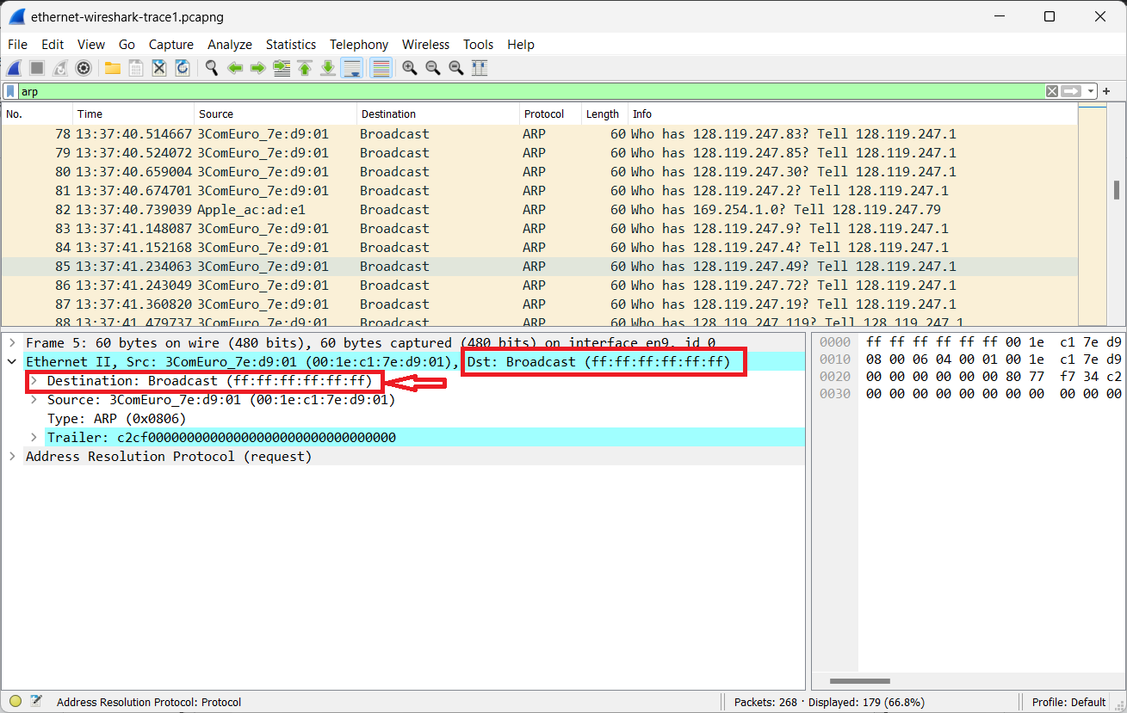

1. The hexadecimal value for the two-byte Ethernet Frame type field is **0x0806**. It corresponds to **ARP protocol**.

